Li-Fi Communication Prototype

Ben Miculob

IEEE # 93658299

Texas Tech University

May 2017

Sponsor Dr. Zhaoyang Fan

Group Members: Cody Cook, Joshua Bayer

Abstract

Li-Fi, an optical form of Wi-Fi communication, uses visible light to maintain communication with other Li-Fi supported devices. A Li-Fi system consists of at least one transmitter and one receiver. The transmitter is a system capable of sending signals through visible light while the receiver is a system capable of receiving these signals. Li-Fi has the ability to create wireless communication channels that will not interfere with RF frequencies. Applicable use cases for Li-Fi would be in RF populated areas where RF is used to communicate with equipment that is given the highest priority. The system discussed in this report focuses on the On-Off keying modulation technique to communicate through one way transmission. There will also be a focus on the hardware used to create the prototyped system.

Table of Contents

List of Figures 4

List of Tables 5

1. What is Li-Fi? 6

1.1 Modulation Techniques 6

1. One-Way Li-Fi System 12
   1. Transmitter LED Driving 13
   2. Receiver Photodetector 15
   3. Microcontroller System 17
2. Communication Between System Storages and Prototyped System 18
   1. System Data to Transmitter Output 19
   2. Receiver Input to System Storage 21
3. Conclusion 22

References 24

Appendix A 25

Appendix B 26

List of Figures

Figure 1: Visible Light Spectrum 6

Figure 2: Manchester Encoding Timing Diagram Example 7

Figure 3: VPPM Encoding Timing Diagram Example 8

Figure 4: 4B6B Pattern Table 9

Figure 5: Color Map and Bit Pattern Map 10

Figure 6: System Block Diagram 13

Figure 7: Switching LED Schematic 14

Figure 8: Switching LED PCB design 15

Figure 9: Receiver Schematic 16

Figure 10: Receiver PCB Design 17

Figure 11: TM4C123GXL Launchpad 18

Figure 12: UART Diagram 19

Figure 13: Queue Data Structure 19

Figure 14: File Transfer Flowchart 20

Figure 15: Transmitter UI 21

Figure 16: Receiver Flow Chart 21

Figure 17: Receiver UI 22

List of Tables

Table 1: PHY I 11

Table 2: PHY II 11

Table 3: PHY III 12

1. What is Li-Fi?

Li-Fi is a form of optical communication using visible light as a medium of for transferring signals. Visible light, being a form of radiation between a wavelength of 400 nm and 700 nm, can be an applicable medium for communication. It is naturally present within society, and can possibly be an applicable alternative for communication. Visible light, has no chance of interference with other signals outside its confined area. It can also be used in conjunction with RF as these two will not interfere with each other. Advantageous applications for Li-Fi would be on airplanes where visible light can supplement passengers with a connection to the internet without interfering with needed communication that is installed on commercial airplanes. Another use case would be in hospitals, as Li-Fi signals will not interfere with any medical instruments such as MRI scanners. A good representation of the range of visible light is illustrated in Figure 1. The numbers represent the wavelength in nanometers.

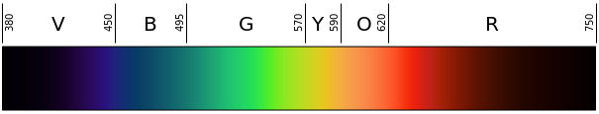

Figure 1: Visible Light Spectrum[1]

* 1. Modulation Techniques

With Li-Fi, there are three different specifications of modulation techniques that are defined by IEEE standards. These are the PHY, short for physical, layers called “PHY I,” “PHY II,” and “PHY III.” This is with reference to the 7-layer OSI model used to represent network the tiers of communication. PHY I is used for outdoor application and uses low data rates. The two main modulation techniques support on-off keying, and variable pulse position modulation. On-off keying uses a sequence of high and low states to represent symbols encoded and decoded by the symbols. In the case of PHY I, data rates go up to 100 kb/s with on off keying and use Manchester encoded signals to send high and low states. Manchester encoded signals use sequence of rising and falling edges to send high and low states. Figure 2 illustrates a timing diagram demonstrating Manchester encoding. Two types of Manchester encoding are demonstrated by this diagram. One follow’s G.E. Thomas’ encoding and the other representing IEEE’s encoding.

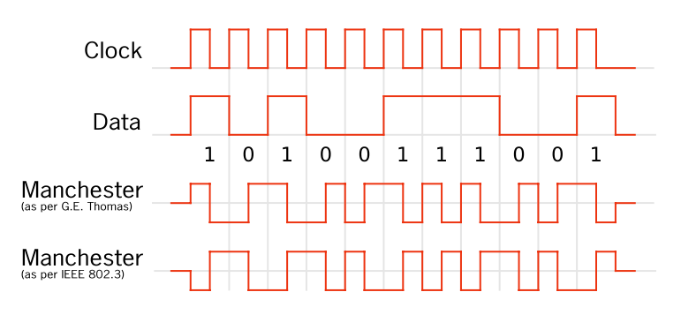

Figure 2: Manchester Encoding Timing Diagram Example[2]

VPPM, or variable pulse position modulation, uses pulses in a specified time period to represent high and low states in the system. These pulses are sent through the optical signal, and the brightness of the signal determines how long the pulse must be. If the pulsed signal begins at the start of the time period and ends between, then the represented symbol is a 0. If the pulsed signal starts between the time period and stops at the end of the time period, then the represented state us a 1. Figure 3 shows a timing diagram of VPPM. This illustrates an example of different brightness levels and their pulse lengths.

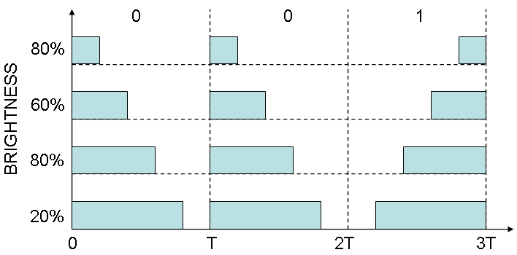

Figure 3: VPPM Encoding Timing Diagram Example[3]

In the case of PHY I, VPPM data rates can go up to 266.6 kb/s using a 4B6B encoding. 4B6B takes 4 bit symbol and translates it into a 6 bit symbol. This is to ensure that there is an even amount of 0’s and 1’s being sent through each encoded symbol. This helps with D.C. balance allowing the prevention of an accumulation of charge across a coupling capacitor.

An example of a 4B6B pattern table is illustrated in Figure 4. In this case hexadecimal symbols are translated into a 6 bit, binary pattern.

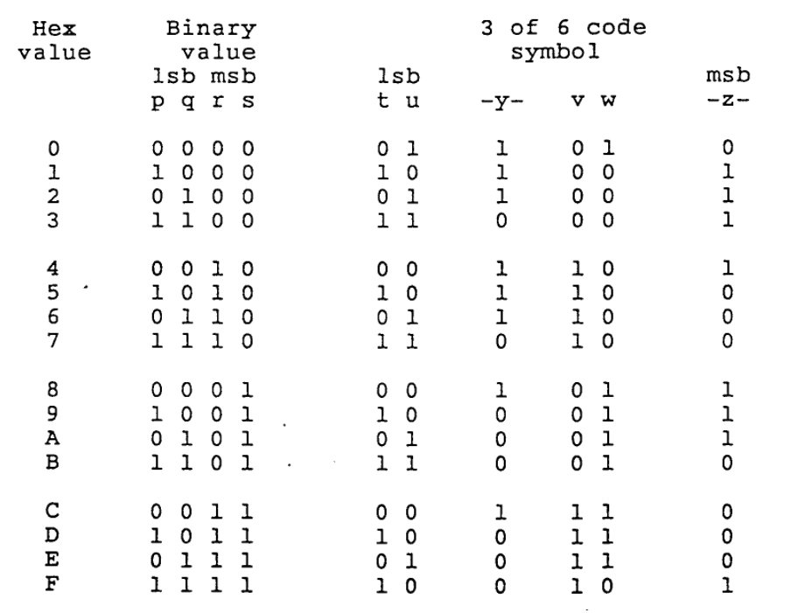

Figure 4: 4B6B Pattern Table[4]

PHY II is used for indoor applications which also uses VPPM and OOK; however, these have much higher data rates than PHY I. The data rates go up by an order of 10 being up to at least 1.25 MB and up. In the case of VPPM, data rates go up to 1.25 Mb/s. With OOK, data rates can go up to 96 Mb/s; however, on-off keying uses 8B10B encoding rather than Manchester. 8B10B is similar to 4B6B, the only difference being that it takes 8 bit patterns and translates them into 10 bit patterns. PHY III layer is different in the case that it only uses one modulation technique. Color shift keying is the main modulation technique used in PHY III. Its data rates achieve a maximum speed similar to PHY II, but its initial clock rates are significantly lower. PHY II’s minimum initial clock rate goes up to 120 MHz at its max speed, 96 Mb/s. PHY III’s minimum clock rate goes up to 24 MHz at a max speed of 96 Mb/s. The reason that CSK is able to achieve this is that CSK uses three channels of light to send symbols. Depending on the sensitivity of the receiver, a CSK can ideally send a large amount of data at once. By encoding a bit pattern into a color combination a CSK symbol can follow a set map of symbols. The length of these symbols determine the type of CSK modulation used. The ones listed in the IEEE standards are 4-CSK, or 2 bit symbols, 8- CSK, or 3 bit symbols, and 16-CSK, or 4 bit symbols. An example of a CSK map is illustrated in Figure 5. This is shows a 16-CSK triangle being mapped onto a color spectrum. The vertices are the primary colors red, green, and blue.

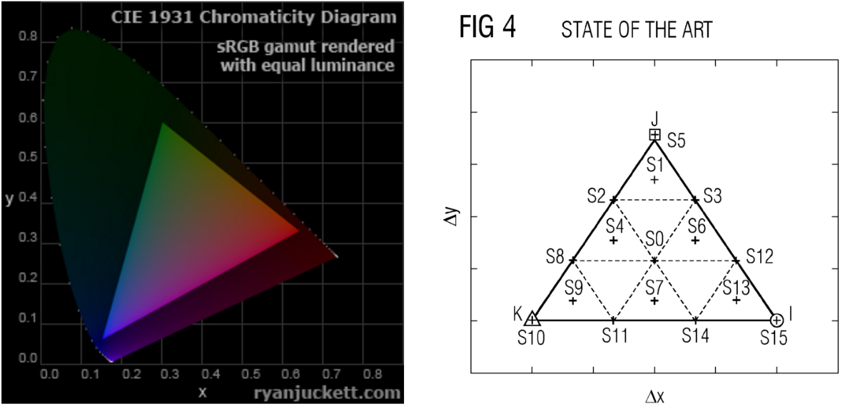

Figure 5: Color Map[5] and Bit Pattern Map[6]

The system that will be discussed focuses on on-off keying that does not use any of the encoding standards listed in the PHY layers. The system will illustrate basic hardware and communication between the transmitter and receiver. Techniques used in the listed PHY layers are used as a basis for the discussed Li-Fi system. Tables 1, 2, and 3 describe all the PHY layers and the modulation techniques used in each PHY layer.

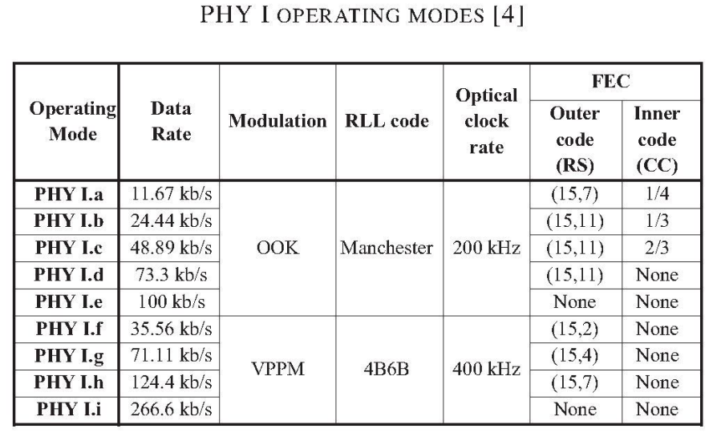

Table 1: PHY I*

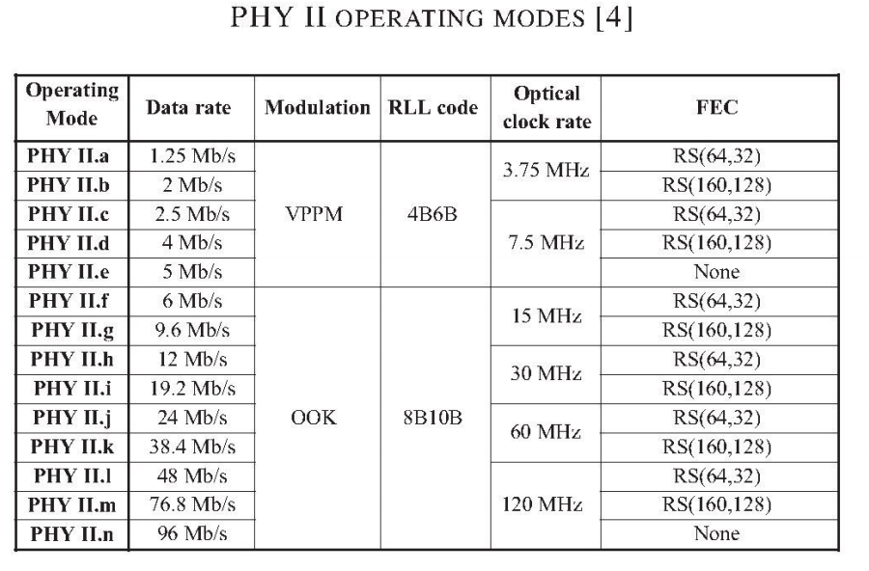  
Table 2: PHY II*[7]

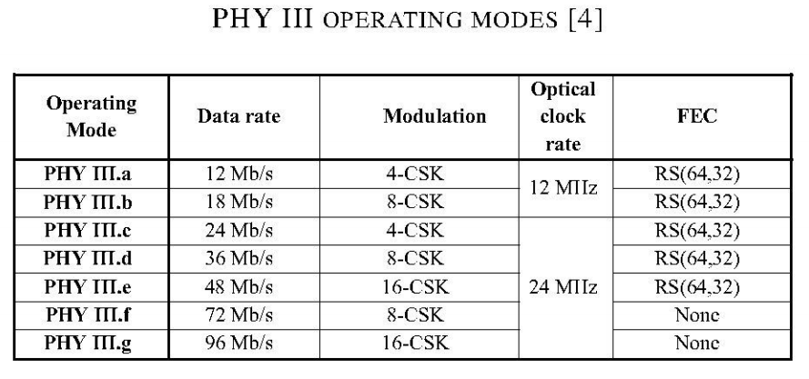

Table 3: PHY III*[8]

1. One-Way Li-Fi System

The system used to test Li-Fi communication consists of hardware only capable of one-way communication. Creating the foundation of our prototype, the system built will test the validity of transferring data through light. This can be tested with a simple transmitter and receiver. The two main things required in the system is that it must be able to switch an LED, and the system must be able to detect the LED pulses. Figure 6 illustrates a conceptual design of the system that is considered.

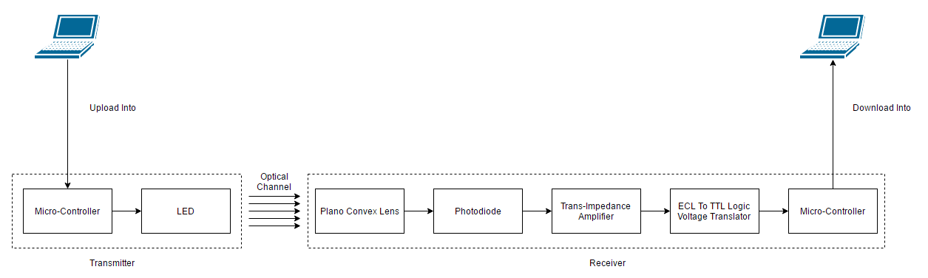

Figure 6: System Block Diagram

* 1. Transmitter LED Driving

Since Li-Fi uses pulsed signals to transmit data, the system must be capable of driving an LED at a high rate. In this case, a transistor will be implemented to allow an adjustable voltage signal to switch the LED while the supply voltage of the LED remains constant. Figure 7 shows the schematic of the transmitter used in this system. The 220 Ω resistor limits the current going into the LED, while it is supplied with a voltage of 12 V. Going into the base of the transistor is the signal that will switch the LED. Our system uses a microcontroller to generate this 3.3 V signal. The 1 kΩ resistor also acts as a current limiter for the signal. This schematic causes the signal to be inverted, so when the signal sends a high, the LED turns off. When the signal sends a low, the LED turns on.

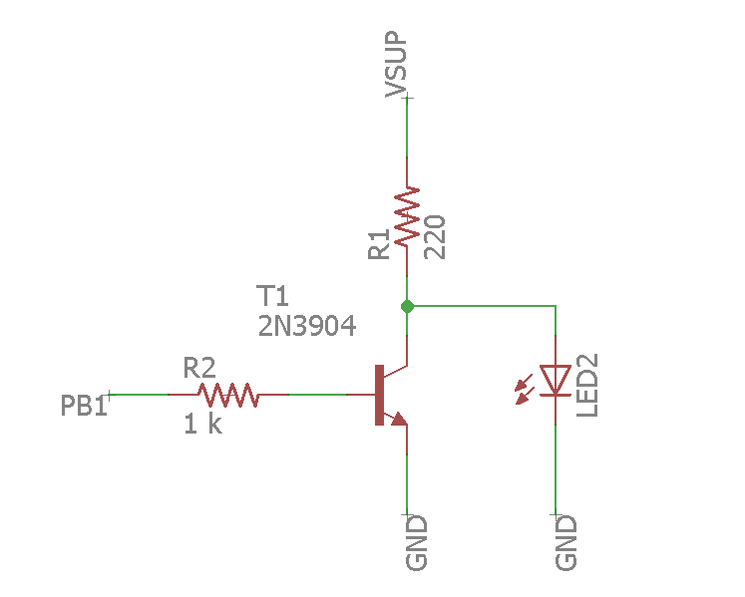

Figure 7: Switching LED Schematic

A board is also designed for this schematic so that it can be easily attached to a TI EK-TM4C123GXL Launchpad, the microcontroller used in our system. Figure 8 shows the design for this board. This board is designed for use with a square surface mount LED of about 2 mm in length. The base is connected to PB1 of the micro controller, and pin 9 on JP1 and pin 10 on JP2 are grounded. The LED must be supplied by an independent voltage source. The dimensions are shown in inches.

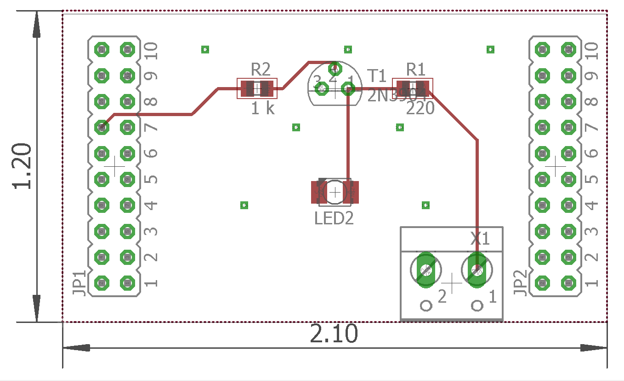

Figure 8: Switching LED PCB design

* 1. Receiver Photodetector

The system must be able to receive visible light signals and interpret them into signals that the hardware will accept. A photodiode is used in this system as the photodetector for the receiver. Figure 9 shows the schematic of the receiver used in the system. The photodiode is reversed biased into the AD8015 which is a trans-impedance amplifier. The capacitor connected to VBYP is used to take away noise from the power supply. According to the data sheet the capacitor value must be chosen using formula 1. Where fmin is the minimum useful frequency.

The trans-impedance amplifier is takes the current generated by the photodiode and outputs a differential voltage. One of the outputs of the differential is then fed into a comparator to translate it into a logic voltage that can be used by a microcontroller. The potentiometer is used to tune the reference voltage of the comparator. With this tested system, the voltage output of the differential output oscillates between 3.7 V and 4.2V. The reference voltage is tuned between these voltages to create a usable logic output. This is an open-drain comparator, so when the signal in the non-inverting output is higher than the reference voltage then the output signal is pulled to ground. When the input signal is lower than the reference voltage then the output voltage is voltage divided by R2 and R3. When used in conjunction with the transmitter circuit described previously, this cancels out the inverted signal generated by the transmitter.

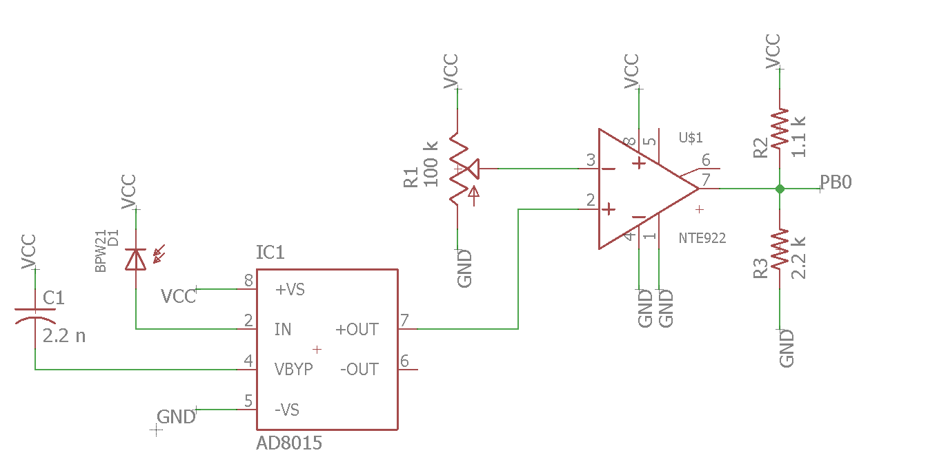

Figure 9: Receiver Schematic

The board design of the receiver schematic is designed while considering the pin layout of the TI EK-TM4C123GXL Launchpad. Figure 10 shows the board design of the receiver schematic. The circuit is powered by the microcontroller which outputs 5 V from pin 10 on JP2.

The left side of pin 8 on JP2 is where the logic is fed into from the receiver. Pin 9 on JP2 and pin 10 on JP10 are connected to the ground planes on the PCB. The board was designed for use with a photodiode with a TO-5 package.

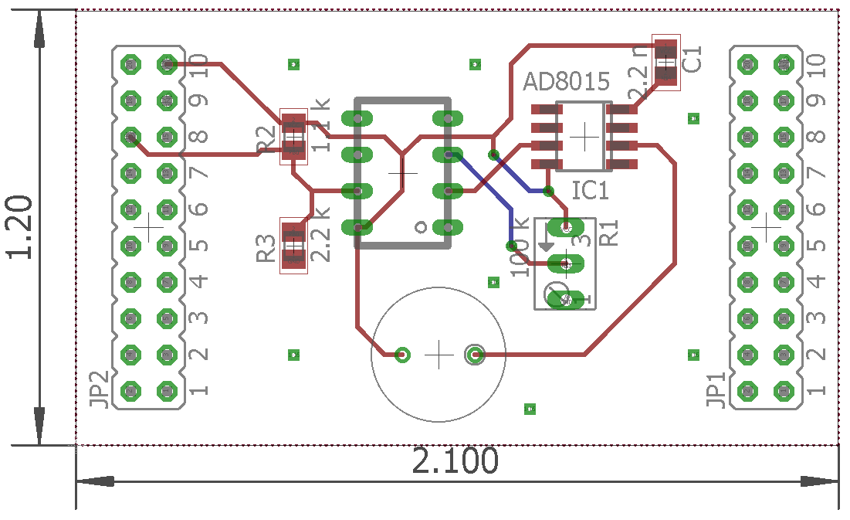

Figure 10: Receiver PCB Design

* 1. Microcontroller System

The current system utilizes two identical microcontrollers which are the TI EK-TM4C123GXL Launchpad. One microcontroller drives the LED on the switching hardware. The other will interpret the visible light signals translated from the receiver hardware. Each of them are connected to system storage device, or a PC in this case, via a USB cord. Each Launchpad houses a TM4C123GH6PM microcontroller, capable of generating and receiving signals in this system. Figure 11 displays the microcontroller that is being used.

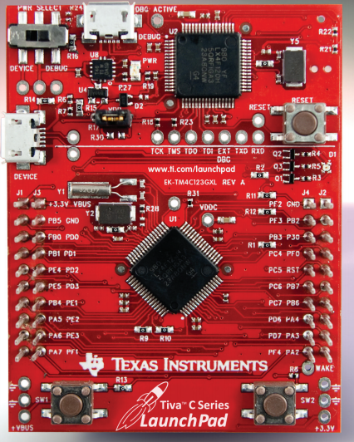

Figure 11: TM4C123GXL Launchpad[9]

1. Communication Between System Storages and Prototyped System

Both of these microcontrollers are connected via USB to a large system storage. In this case, a PC loaded with a Windows 10 operating system. The communication protocol used between these components is UART. UART uses on-off keying to send packets of bits through a data stream. UART is configured at a specific baud rate which is the amount of symbols that are sent per period of time. Connection between the PC, microcontroller, and transmitter/receiver all use the UART communication protocol. Figure 12 shows a simple timing diagram of 8 bit UART communication. The start bit is a low signal for the specified time period. The stop bit is a high signal for a specified time period. The stop bit length can be either 1, 1.5, or 2 times the time period per bit of data.

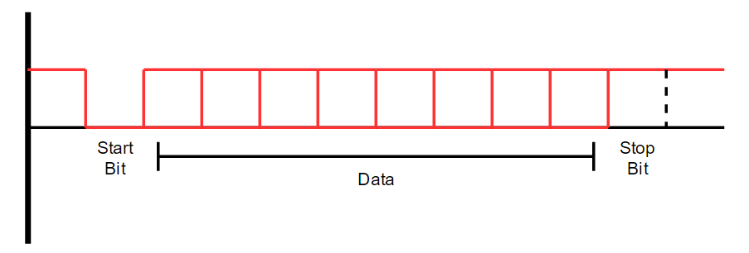

Figure 12: UART Diagram

Regarding the software within the microcontroller on the receiver and transmitter, there is a queue that acts as a buffer for the data. Since the UART uses the FIFO method of sending data, a queue is an applicable data structure for streaming bits. As bits of data are loaded into the queue, those bits are then outputted to the specified system. Data will output into either the transmitter, or the system storage. Figure 13 shows an example of the queue data structure. There are head and tail indexes. The head shows where the next data should be place, while the tail shows which data should be sent next.

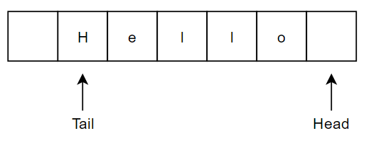

Figure 13: Queue Data Structure

* 1. System Data to Transmitter Output

Using the communication protocol implemented, the user will be able to load data into the transmitter via the UART communication protocol. Since a file, at its most basic components, is a sequence of binary patterns, translating the data into a signal is not complex. The system is able to take the file as is, and translate it to an on-off keying sequence. Data is read through in sections of bytes, so the UART communication will send the data in packets of 8 bits. Figure 14 illustrates a flowchart of how data streaming system will work on the transmitter side. In this case the file transfer starts with the user selecting a file and transmitting it. It takes the file and splits it into UART packets, then it transmits each of those packets till it reaches the end of the file.

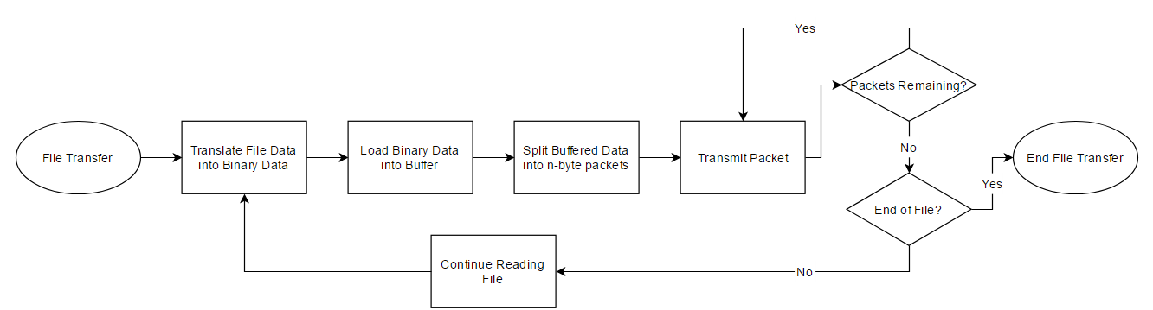

Figure 14: File Transfer Flowchart

In order to make this process simple for the user, a UI can be implemented in the system. Figure 15 shows the UI designed for testing the transmitter side of the system. The user is able to configure which port the microcontroller is connected to. The user must set the baud rate at which the microcontroller is set to. The data bits and stop bits also must be configured at which the microcontroller is set to. The test button allows the user to send a test signal to verify if data is able to be streamed. The user is able to browse the system storage and choose a file to transmit. Once the file is choose the user must use the transmit button to transmit the file through the transmitter.

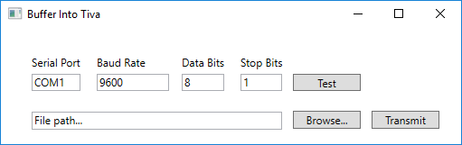

Figure 15: Transmitter UI

* 1. Receiver Input to System Storage

The storage system connected to the Li-Fi prototyped system will be able to receive and save data from the receiver. This also uses the UART communication protocol which gets data from the receiver and saves it onto the system storage. Figure 16 shows this process of taking data and saving it to the storage. The UART communication is implemented between the two diamond blocks representing the stop bit and start bit. It writes each of these packets to the system storage as soon as the packet is received.

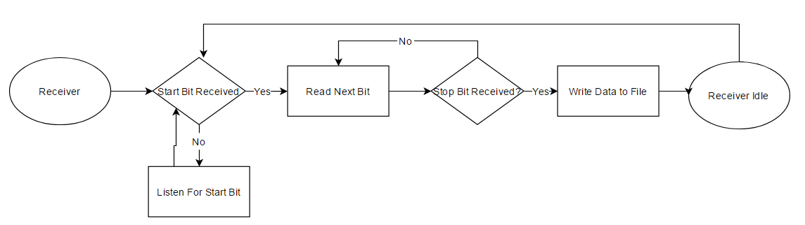

Figure 16: Receiver Flow Chart

A UI is implemented for the receiver to promote ease of access to the system. Figure 17 shows the UI that is used to get the file data. The same as the transmitter UI, the user is able to configure the serial port, baud rate, data bits, and stop bits. Once this is configured, the user must select a file path to save it to using the browse button. The user can also type the file path manually. Once all of this is configured, the user must toggle the connection open to generate space for the file. The Incoming Data box shows the data being received in pure ASCII format. There is also a grey box to indicate whether or not it is still receiving data. The box turns green while data is being received by the receiver. Once it has been verified that the data transmission has ended, the user must toggle the connection closed in order to save the file. The clear button allows the user to clear the incoming data text box for any other file transfers.

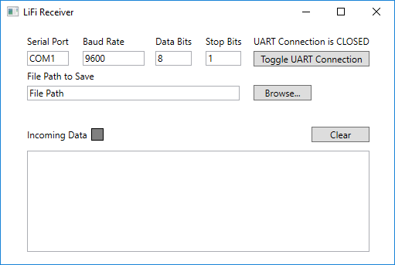

Figure 17: Receiver UI

1. Conclusion

According to the prototyped system, Li-Fi is a valid means of communication. The system is able transmit and receive files via one way transmission at a rate of 200 kb/s or 25 kB/s at a distance of 2 feet. In order to make this a true Li-Fi system the transmitter and receiver must now be converted into transceivers. Wi-Fi uses two-way communication to reliably transfer data and maintain connection. More improvements could be made to this system. For example, instead of using a comparator to translate the voltage differential, use a differential amplifier to amplify the voltage difference outputted from the trans-impedance amplifier. This will take away the required tweaking of the potentiometer on the receiver schematic. Even so, the system is capable of one-way communication through visible light and is able to transfer files reliably at a relatively short range.

References

1. Visible Light Spectrum Figure:

<https://commons.wikimedia.org/w/index.php?curid=4639774>

1. Manchester Timing Diagram Figure:

<https://commons.wikimedia.org/w/index.php?curid=4639774>

1. VPPM Timing Diagram Figure:

<http://visiblelightcomm.com/an-ieee-standard-for-visible-light-communications/vppm/>

1. 4B6B Coding Scheme Patent:

<https://www.google.com/patents/EP0629068A1>

1. PHY layer performance evaluation of the IEEE 802.15.7 visible light communication standard:

<http://ieeexplore.ieee.org/document/6777772/>

1. Coding Scheme And Method For A Colour-Shift-Keying Constellation In A Visible-Light Communication System Patent:

<https://www.google.com/patents/US20130308955>

1. Tiva™ C Series TM4C123G LaunchPad Evaluation Kit:

<http://www.ti.com/lit/ml/spmt281a/spmt281a.pdf>

Appendix A

Gantt Chart



Appendix B

Budget

|  |  |  |  |
| --- | --- | --- | --- |
| **Component** | **Amount** | **Price per component** | **Total cost of components** |
| Microcontroller - MSP430 | 2 | $12.99 | $25.98 |
| Photodiode - BPW 21 | 2 | $9.38 | $18.76 |
| LDE - L1C1-GRN1000000000 | 5 | $2.73 | $13.65 |
| [EK-TM4C123GXL](http://www.ti.com/tool/ek-tm4c123gxl) (Tiva Launchpad) | 2 | $12.99 | $25.98 |
| AD8656 (Amplifier) | 2 | $3.45 | $6.90 |
| **Staff** | **Hours** | **Hourly wage** | **Total** |
| Engineer 1 | 280 | $20.00 | $5,600 |
| Engineer 2 | 280 | $20.00 | $5,600 |
| Engineer 3 | 280 | $20.00 | $5,600 |
|  |  |  | **Grand Total** |
|  |  |  | $16,891.27 |

1. By Gringer - Own work, Public Domain
2. By Stefan Schmidt - Enhancement of Manchester Encoding, Public Domain
3. By gordonpovey
4. From 4B6B Coding Scheme Patent
5. PHY layer performance evaluation of the IEEE 802.15.7 visible light communication standard
6. Coding Scheme And Method For A Colour-Shift-Keying Constellation In A Visible-Light Communication System
7. * PHY layer performance evaluation of the IEEE 802.15.7 visible light communication standard
8. * PHY layer performance evaluation of the IEEE 802.15.7 visible light communication standard
9. From the Tiva LaunchPad Evaluation Kit PDF